**Temperature Influences the Survival of Frog Populations Infected with *Batrachochytrium dendrobatidis***

By: Rachel Rodriguez, Riho Ishida, and Alicia Magsano

**Abstract**

The fungal pathogen *Batrachochytrium dendrobatidis* (Bd) is responsible for significant declines in amphibian populations worldwide, as it causes the lethal skin disease chytridiomycosis. With Bd favouring cooler temperatures, this study aimed to identify climate change’s effect on frog populations infected with Bd. Therefore, a thermal performance curve (TPC) of Bd was created alongside a stage-structured SIR model to simulate possible survival outcomes for an infected frog population at a given temperature. The TPC revealed a thermal optimum of 15℃ for Bd zoospores. Additionally, the simulations indicated that the survival of a frog population was influenced by temperature’s impact on the initial zoospore count, which determined the severity of the infection within the population. As a result, temperature influenced the fraction of populations that went extinct and those that fell below 50% of their initial size. Therefore, in the context of climate change, tropical populations will benefit as temperatures increase away from Bd’s thermal optimum, while populations in cooler climates will suffer as temperatures are brought closer to 15℃.

**Introduction**

*Batrachochytrium dendrobatidis* (Bd) is a fungal pathogen that causes the skin disease chytridiomycosis, which is lethal for many amphibian species (Piotrowski et al., 2004; Scheele et al., 2019). Bd’s impact represents “the greatest recorded loss of biodiversity attributable to a disease” (Scheele et al., 2019), as it has contributed to the decline of at least 501 amphibian species and 90 presumed extinctions worldwide (Scheele et al., 2019). Given its lethality, understanding how to combat this deadly pathogen is crucial.

One factor that could help combat Bd is temperature, as Bd has a thermal tolerance range of 2–28°C (Voyles et al., 2017). Studies have also shown that Bd zoospore activity decreases as temperature increases (Sapsford et al., 2013; Stevenson et al., 2013). In vivo experiments further support this, as hosts treated at higher temperatures have reduced mortality (Berger et al., 2004). Therefore, understanding how climate change impacts infected populations is vital for the conservation of these affected species.

Previous studies have used modelling to predict how Bd's range may shift in response to climate change or how the dynamics of infected frog populations may change given existing temperature profiles (Ackleh et al., 2016; Sun et al., 2023). However, no studies have explicitly examined the effect of a given temperature on the dynamics of a population infected with Bd. To address this knowledge gap, we created a thermal performance curve (TPC) for Bd and a mathematical model to simulate an infected frog population at various temperatures. We predicted that the probability of extinction for an infected frog population would be lower at higher temperatures, thus reflecting Bd’s thermal tolerance range.

**Methods**

Data Description

The data we used combined the zoospore count and temperature (℃) data collected by three studies. Two of the studies were field studies conducted in Australia which looked at how different environmental factors influenced Bd prevalence in frogs from the genus *Litoria* (Kriger et al., 2007; Kriger & Hero, 2007). The third study was a lab study examining how temperature affected different Bd isolates from the United States (Sheets et al., 2021).

Data Analysis

To determine Bd’s thermal optimum, we first created a TPC for Bd using the combined data. To account for the data’s high variance, we modelled the relationship between temperature and zoospore count using a negative binomial distribution. The parameters used to model this relationship included the average maximum number of zoospores produced at the thermal optimum (A), Bd zoospores' optimum temperature (Topt), the width around the thermal optimum (w), and the dispersion coefficient (size). We then tested combinations of these parameters to find a maximum likelihood estimate for the TPC.

Next, we created a mathematical model to study Bd’s spread through motile zoospores and direct skin contact in an infected population (Carey et al., 2006; Rowley & Alford, 2007). The model included equations for environmental zoospores (equation 1) and a stage-structured SIR model as Bd can infect both frogs and tadpoles (Skerratt et al., 2007). The SIR model tracked changes in susceptible and infected tadpoles (equations 2 & 3 respectively) and frogs (equations 4 & 5 respectively) over time, using the variables in Table 1. Key assumptions included no vertical transmission so only susceptible tadpoles are born, and infected tadpoles mature into infected frogs as Bd can persist after metamorphosis. (Infection with *Batrachochytrium Dendrobatidis*, 2020; McMahon & Rohr, 2015). Recovery was also excluded due to Bd’s high mortality rate (Berger et al., 2005). Additionally, we assumed there was homogeneous mixing, which ignores possible ecological barriers and behavioural patterns (Tolles & Luong, 2020). Similarly, zoospore infection probability was assumed equal, ignoring the effect of random chance, isolate type, and ecological barriers. Furthermore, parameters like tadpole maturation or Bd’s virulence in tadpoles vs frogs were estimated and thus do not reflect empirical evidence (Rauw, 2012; Skerratt et al., 2007).

Finally, to determine how temperature affects a Bd-infected frog population, we performed 100 simulations using a stochastic version of our model at 10, 15, and 25℃. The model was made stochastic by assigning rates to all possible events, with each event occurring based on its rate and a time interval between all events. Each simulation started with 100 susceptible tadpoles, lasted 1 year, and the initial zoospore count was determined by the TPC. The values of the remaining parameters used in the simulation are listed in Table 1.

**Results**

Based on the TPC (Figure 1), the thermal optimum for Bd zoospores was 15℃, and the TPC itself was symmetrical.

The results of the population simulations at each temperature followed a similar pattern where at time zero the number of infected individuals spiked following the initial introduction of zoospores and depending on the infection’s severity, the total population either went extinct or survived after 1 year (Figure 2). This trend is supported by the bimodal distribution of frog population sizes after 1 year (Figure 3). However, at temperatures closer to Bd’s thermal optimum (15℃) the distribution skewed towards extinction while at 25℃ the distribution was more balanced (Figure 3).

Temperature also influenced the initial number of zoospores because at 10 and 15℃ the initial zoospore count was considerably higher compared to when the simulation was done at 25℃ (Figure 4). Additionally, there was an inverse relationship between the initial zoospore count and final population size as the higher the initial zoospore count, the more likely it was for frog populations to go extinct (Figure 4). Furthermore, if the initial zoospore count was above 5000, frog populations almost always went extinct (Figure 4).

The fraction of populations that went extinct and the fraction of populations that fell below 50% of their initial population size were also impacted by temperature as both values were higher at temperatures closer to Bd’s thermal optimum of 15℃ (Table 2).

**Discussion**

The optimum temperature derived from our TPC was lower than the literature values of 17-25℃ (Bradley et al., 2019; Piotrowski et al., 2004). We speculate this is due to the limitations of our data as the field study was restricted to reservoir hosts that can survive with a higher load of Bd (Retallick et al., 2004). Additionally, the lab study used different Bd isolates and evidence suggests that thermal optimums can vary by isolates (Voyles et al., 2017). As a result, such aspects of our data could have skewed the TPC.

The results from the simulations support our prediction as replicates with higher temperatures had lower initial zoospore counts and, consequently, a larger population size at the end of the simulation. This is reflected as the fraction of extinct populations follows a bell curve around Bd’s optimum temperature. These results elicit two possible effects in the context of climate change. For tropical areas with already warm temperatures, global warming could cause the average temperature to rise above 15℃ and favour the survival of frogs. However, for colder areas, it could bring the average temperature closer to Bd’s optimum, thus favouring the production of zoospores and increasing the risk of extinction.

Our work serves as a generalized model and thus has limitations like simplified factors or assumed parameters, such as the role of other abiotic factors, frog species, and Bd’s spread (Infection with *Batrachochytrium Dendrobatidis*, 2020; Lips, 2016; Raffel et al., 2015). In the future, the model can be modified to incorporate more complex interactions or adjusted to reflect a frog species of interest. Authors involved in field studies could also use their data to construct a TPC that reflects the isolate of Bd they are working with.

**Equations**

Zoospores

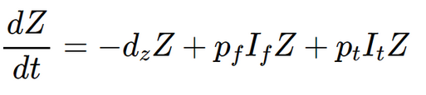

(1)

Susceptible/Infected Tadpoles

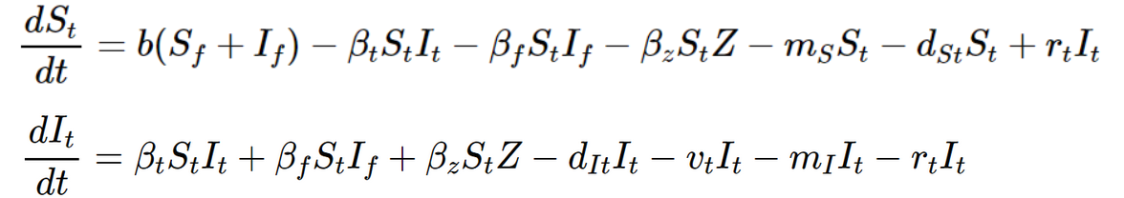

(2)



(3)

Susceptible/Infected Frogs

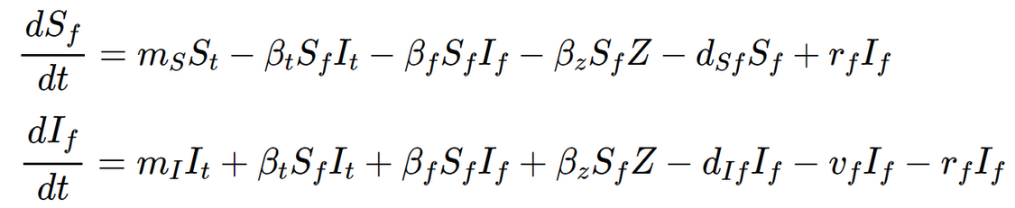

(4)



(5)

**Figures & Tables**

**Table 1. Descriptions of the model’s variables and parameters and their associated values and sources.** If a source was not provided, that parameter was given a general value that is not based on empirical estimates.

|  |  |  |  |
| --- | --- | --- | --- |
| **Variables/Parameter** | **Description** | **Value** | **Source** |
| Z | Number of zoospores | - | - |
| St | Number of susceptible tadpoles | - | - |
| It | Number of infected tadpoles | - | - |
| Sf | Number of susceptible frogs | - | - |
| If | Number of infected frogs | - | - |
| pt | Zoospore production rate from infected tadpoles | 1 x 10-3 | - |
| pf | Zoospore production rate from infected frogs | 1 x 10-3 | - |
| ms | Maturation rate of susceptible tadpoles | 1/78 | (Heard et al., 2011) |
| mI | Maturation rate of infected tadpoles | 1/78 | (Heard et al., 2011) |
| b | Birth rate of tadpoles | 1/365 | - |
| rt | Recovery rate of tadpoles | 0 | (Berger et al., 2005) |
| rf | Recovery rate of frogs | 0 | (Berger et al., 2005) |
| vt | Death rate caused by Bd in tadpoles | 1/21 | (*Chytridiomycosis*, n.d.) |
| vf | Death rate caused by Bd in frogs | 1/21 | (*Chytridiomycosis*, n.d.) |
| βt | Rate of infection from tadpoles | 1 x 10-3 | - |
| βf | Rate of infection from frogs | 1 x 10-3 | - |
| βz | Rate of infection from environmental zoospores | 1 x 10-3 | - |
| dz | Death rate of zoospores | 2 | - |
| dSt | Death rate of susceptible tadpoles | 1/365 | - |
| dIt | Death rate of infected tadpoles | 1/365 | - |
| dSf | Death rate of susceptible frogs | 1/365 | - |
| dIf | Death rate of infected frogs | 1/365 | - |

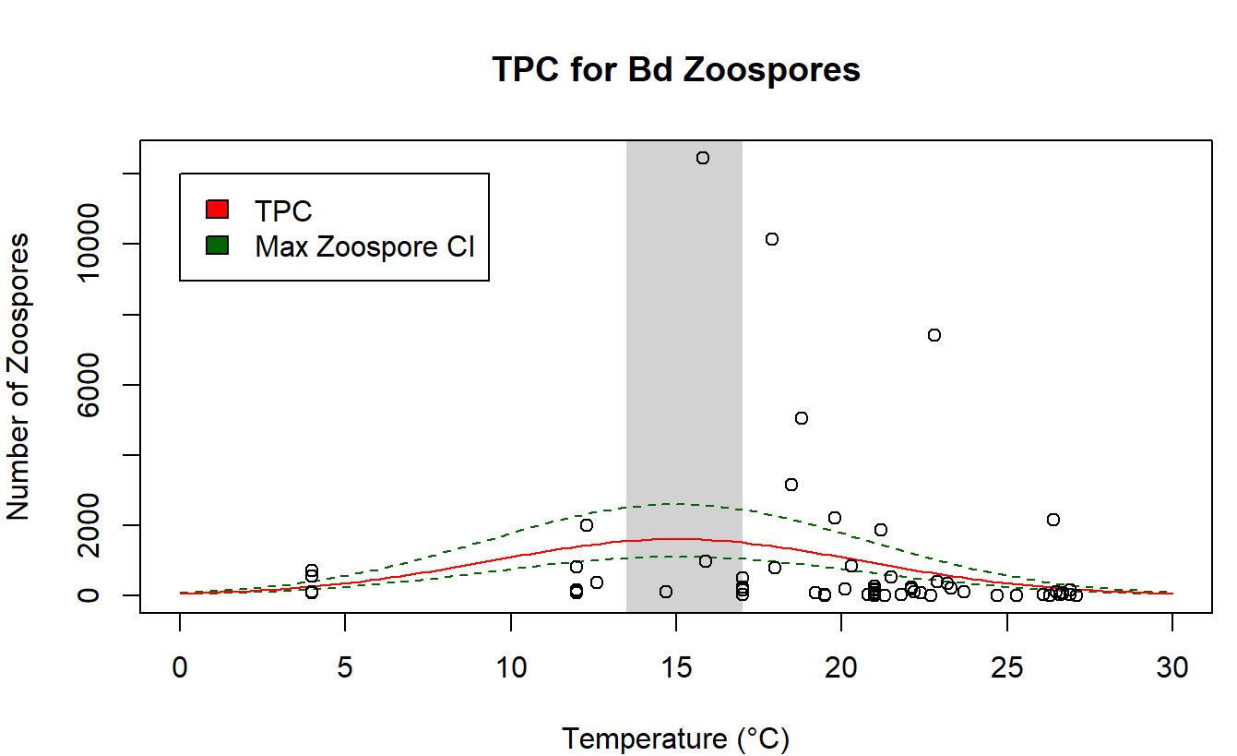

**Figure 1. Thermal performance curve for Bd zoospores.** The solid red line represents the TPC, and the two dashed green lines show the max zoospore confidence interval across the TPC. The vertical grey bar shows the confidence interval for Bd’s thermal optimum and the dots behind the TPC are the data points from the combined dataset.

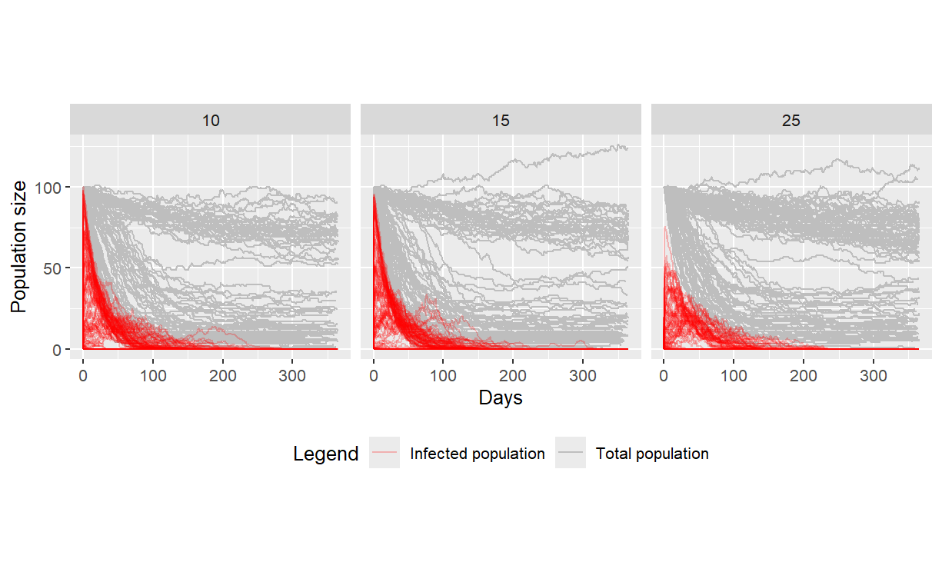

**Figure 2. Changes in total and infected population size over 1 year.** Each line is a replicate with the grey lines representing the total population and the red lines representing only the infected individuals in the population. The number above each graph indicates the temperature each simulation was conducted under.

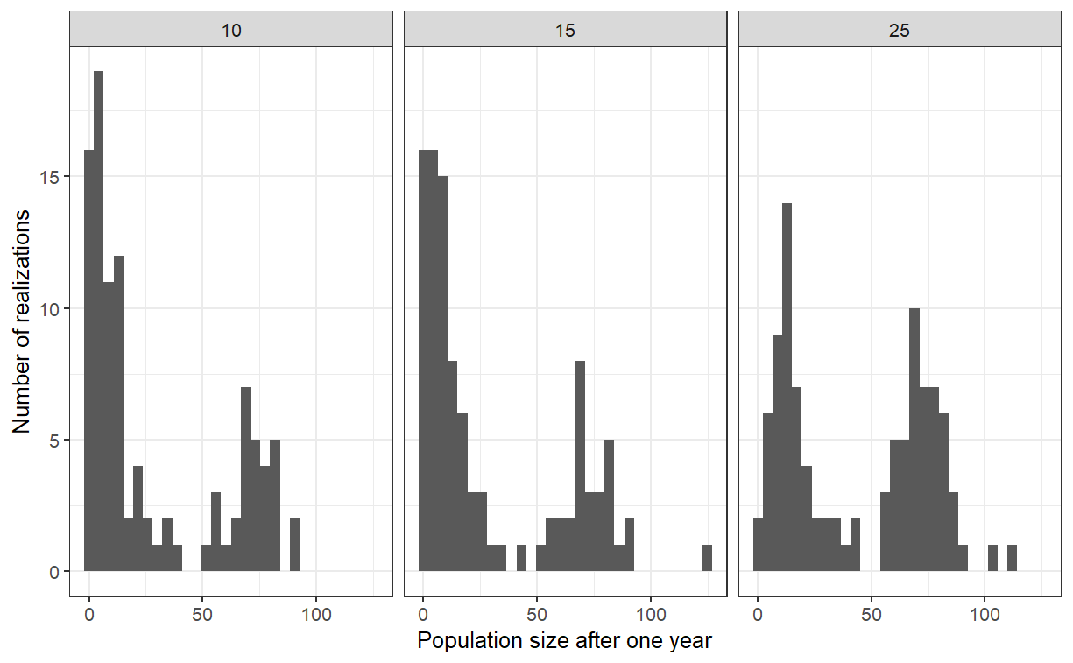

**Figure 3. Distribution of population sizes after 1 year.** The histogram shows the distribution of population sizes at the end of the simulation. The number above each graph indicates the temperature each simulation was conducted under.

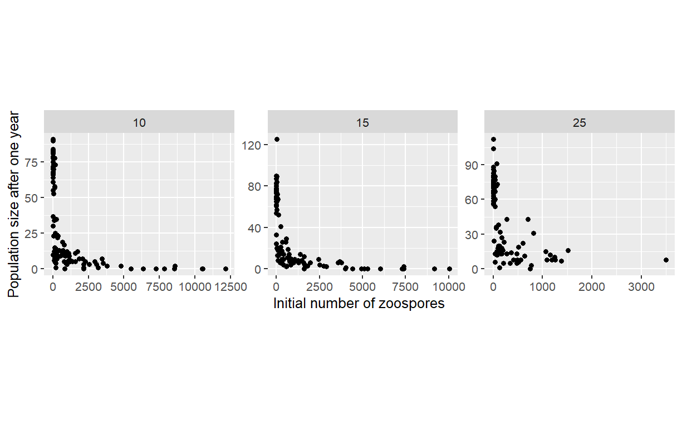

**Figure 4. Initial zoospore count’s effect on population size.** Each dot represents a replicate. The number above each graph indicates the temperature each simulation was conducted under.

**Table 2. Fraction of populations that went extinct or fell below 50% of their initial population size.**

|  |  |  |
| --- | --- | --- |
| **Temperature (℃)** | **Fraction of Extinct Populations** | **Fraction of Populations Reduced Below 50%** |
| 10 | 0.10 | 0.71 |
| 15 | 0.11 | 0.71 |
| 25 | 0.01 | 0.51 |

**Supplementary Material**

The code used to generate the TPC and conduct the modelling simulation can be accessed through the R markdown file called “[Bd_TPC&modelling_code.Rmd](https://github.com/EEB313/2024-GroupD/blob/9042067b1c8e3a67abbe6510eaccb13153289b9d/Bd_TPC%26modelling_code.Rmd)”. Furthermore, the combined dataset can be accessed using the “[combined_chytrid_data.csv](https://github.com/EEB313/2024-GroupD/blob/ce9042d4126570023c309cb1043bac25cadbfc0b/combined_chytrid_data.csv)” file and the results of the simulations presented in this report can be accessed through the “[simulations_results.csv](https://github.com/EEB313/2024-GroupD/blob/9b5dc047ed42084fbfe49bd12c371d14deb69ca3/simulation_results.csv)” file. A description of both these files can be accessed through the “[Data Description.docx](https://github.com/EEB313/2024-GroupD/blob/717545a686182d0ff4e01522b30650240eb92b92/Data%20Description.docx)” file.

**References**

Ackleh, A. S., Carter, J., Chellamuthu, V. K., & Ma, B. (2016). A model for the interaction of

frog population dynamics with *Batrachochytrium dendrobatidis*, Janthinobacterium lividum and temperature and its implication for chytridiomycosis management.

*Ecological Modelling*, *320*(24), 158–169. <https://doi.org/10.1016/j.ecolmodel.2015.09.015>

Berger, L., Hyatt, A. D., Speare, R., & Longcore, J. E. (2005). Life cycle stages of the

amphibian chytrid *Batrachochytrium dendrobatidis*. *Diseases of Aquatic Organisms*, *68*(1), 51–63. https://doi.org/10.3354/dao068051

Berger, L., Speare, R., Hines, H., Martelli, G., Hyatt, A., McDonald, K., Skerratt, L., Olsen,

V., Clarke, J., Gillespie, G., Mahony, M., Sheppard, N., Williams, C., & Tyler, M. (2004). Effect Of Season And Temperature On Mortality In Amphibians Due To Chytridiomycosis. *Australian Veterinary Journal, 82*(7), 434–439. <https://doi.org/10.1111/j.1751-0813.2004.tb11137.x>

Bradley, P. W., Brawner, M. D., Raffel, T. R., Rohr, J. R., Olson, D. H., Blaustein, A. R., &

Kerby, J. (2019). Shifts in temperature influence how *Batrachochytrium dendrobatidis* infects amphibian larvae. *PloS One, 14*(9), e0222237–e0222237. https://doi.org/10.1371/journal.pone.0222237

Carey, C., Bruzgul, J. E., Livo, L. J., Walling, M. L., Kuehl, K. A., Dixon, B. F., Pessier, A.

P., Alford, R. A., & Rogers, K. B. (2006). Experimental Exposures of Boreal Toads (*Bufo boreas*) to a Pathogenic Chytrid Fungus (*Batrachochytrium dendrobatidis*). *EcoHealth*, *3*(1), 5–21. https://doi.org/10.1007/PL00021734

*Chytridiomycosis*. (n.d.). Ohio Department of Natural Resources Division of Wildlife. https://dam.assets.ohio.gov/image/upload/ohiodnr.gov/documents/wildlife/wildlife-management/Chytridiomycosis%20Amphibians.pdf

Heard, G. W., Scroggie, M. P., Malone, B. S. (2011). The life history and decline of the

threatened Australian frog *Litoria raniformis*. *Austral Ecology*, *37*(2), 276-284. <https://doi.org/10.1111/j.1442-9993.2011.02275.x>

*Infection with Batrachochytrium dendrobatidis*. (2020). Australia Government, Department

of Agriculture, Water and the Environment. https://www.agriculture.gov.au/sites/default/files/documents/infection-batrachochytrium-denrobatidis.pdf

Kriger, K. M., & Hero, J.-M. (2007). Large-scale seasonal variation in the prevalence and

severity of chytridiomycosis. *Journal of Zoology (1987)*, *271*(3), 352–359. <https://doi.org/10.1111/j.1469-7998.2006.00220.x>

Kriger, K. M., Pereoglou, F., & Hero, J. M. (2007). Latitudinal Variation in the Prevalence

and Intensity of Chytrid (*Batrachochytrium dendrobatidis*) Infection in Eastern Australia. *Conservation Biology, 21*(5), 1280–1290. <https://doi.org/10.1111/j.1523-1739.2007.00777.x>

Lips, K. R. (2016). Overview of chytrid emergence and impacts on amphibians.

*Philosophical Transactions of the Royal Society of London. Series B. Biological Sciences, 371*(1709), 20150465-. https://doi.org/10.1098/rstb.2015.0465

McMahon, T. A., & Rohr, J. R. (2015). Transition of Chytrid Fungus Infection from

Mouthparts to Hind Limbs During Amphibian Metamorphosis. *EcoHealth*, *12*(1), 188–193. https://doi.org/10.1007/s10393-014-0989-9

Piotrowski, J. S., Annis, S. L., & Longcore, J. E. (2004). Physiology of Batrachochytrium

dendrobatidis, a Chytrid Pathogen of Amphibians. *Mycologia*, *96*(1), 9--. <https://doi.org/10.2307/3761981>

Raffel, T. R., Halstead, N. T., McMahon, T. A., Davis, A. K., & Rohr, J. R. (2015).

Temperature variability and moisture synergistically interact to exacerbate an epizootic disease. *Proceedings of the Royal Society. B, Biological Sciences, 282*(1801), 20142039–20142039. https://doi.org/10.1098/rspb.2014.2039

Rauw, W. M. (2012). Immune response from a resource allocation perspective. *Frontiers in*

*Genetics, 3*, 267–267. <https://doi.org/10.3389/fgene.2012.00267>

Retallick, R. W. R., McCallum, H., Speare, R., & Georgina M. Mace. (2004). Endemic

infection of the amphibian chytrid fungus in a frog community post-decline. *PLoS Biology, 2*(11), e351–e351. https://doi.org/10.1371/journal.pbio.0020351

Rowley, J. J. L., & Alford, R. A. (2007). Behaviour of Australian rainforest stream frogs may

affect the transmission of chytridiomycosis. *Diseases of Aquatic Organisms*, *77*(1), 1–9. https://doi.org/10.3354/dao01830

Sapsford, S. J., Alford, R. A., & Schwarzkopf, L. (2013). Elevation, Temperature, and

Aquatic Connectivity All Influence the Infection Dynamics of the Amphibian Chytrid Fungus in Adult Frogs. *PloS One, 8*(12), e82425–e82425. https://doi.org/10.1371/journal.pone.0082425

Scheele, B. C., Pasmans, F., Skerratt, L. F., Berger, L., Martel, A., Beukema, W., Acevedo, A.

A., Burrowes, P. A., Carvalho, T., Catenazzi, A., De la Riva, I., Fisher, M. C., Flechas, S. V., Foster, C. N., Frías-Álvarez, P., Garner, T. W. J., Gratwicke, B., Guayasamin, J. M., Hirschfeld, M., … Canessa, S. (2019). Amphibian fungal panzootic causes catastrophic and ongoing loss of biodiversity. *Science*, *363*(6434), 1459–1463. <https://doi.org/10.1126/science.aav0379>

Sheets, C. N., Schmidt, D. R., Hurtado, P. J., Byrne, A. Q., Rosenblum, E. B.,

Richards-Zawacki, C. L., & Voyles, J. (2021). Thermal Performance Curves of Multiple Isolates of *Batrachochytrium dendrobatidis*, a Lethal Pathogen of Amphibians. *Frontiers in Veterinary Science*, *8*, 687084–687084. <https://doi.org/10.3389/fvets.2021.687084>

Skerratt, L. F., Berger, L., Speare, R., Cashins, S., McDonald, K. R., Phillott, A. D., Hines, H.

B., & Kenyon, N. (2007). Spread of Chytridiomycosis Has Caused the Rapid Global Decline and Extinction of Frogs. *EcoHealth*, *4*(2), 125–134. https://doi.org/10.1007/s10393-007-0093-5

Stevenson, L. A., Alford, R. A., Bell, S. C., Roznik, E. A., Berger, L., & Pike, D. A. (2013).

Variation in Thermal Performance of a Widespread Pathogen, the Amphibian Chytrid Fungus *Batrachochytrium dendrobatidis. PLoS ONE, 8*(9), e73830. <https://doi.org/10.1371/journal.pone.0073830>

Sun, D., Ellepola, G., Herath, J., & Meegaskumbura, M. (2023). The two chytrid pathogens

of amphibians in Eurasia—climatic niches and future expansion. *BMC Ecology and Evolution*, *23*(1), 26–26. <https://doi.org/10.1186/s12862-023-02132-y>

Tolles, J., & Luong, T. (2020). Modeling Epidemics With Compartmental Models. *JAMA :*

*The Journal of the American Medical Association*, *323*(24), 2515–2516. https://doi.org/10.1001/jama.2020.8420

Voyles, J., Johnson, L. R., Rohr, J., Kelly, R., Barron, C., Miller, D., Minster, J., &

Rosenblum, E. B. (2017). Diversity in growth patterns among strains of the lethal fungal pathogen *Batrachochytrium dendrobatidis* across extended thermal optima. *Oecologia*, *184*(2), 363–373. https://doi.org/10.1007/s00442-017-3866-8